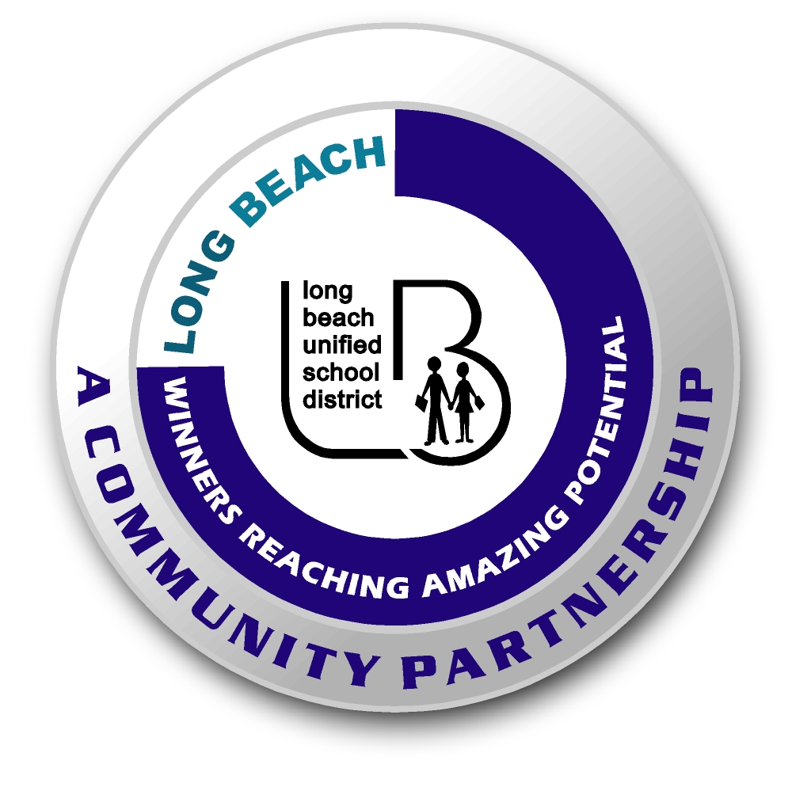
Long Beach WRAP

Academic Enrichment Lesson Outline

Date: __________ Grade Level: ________

Theme for the Month: ________________________ School Site: __________________________________

Topic of Lesson : ____________________________ Program Leader: ______________________________

Approximate Time Needed: ____________________

Content Standard(s)______________________________________________________________________

_______________________________________________________________________________________

What will be learned from this activity? (objective) _____________________________________________

Steps of the lesson:

Introduction: ___________________________________________________________________________

______________________________________________________________________________________

Instruction: ____________________________________________________________________________

______________________________________________________________________________________

______________________________________________________________________________________

______________________________________________________________________________________

Activity:_______________________________________________________________________________

______________________________________________________________________________________

______________________________________________________________________________________

______________________________________________________________________________________

______________________________________________________________________________________

______________________________________________________________________________________

Closure: ______________________________________________________________________________

______________________________________________________________________________________

______________________________________________________________________________________

Materials and Quantity Needed: (be specific)__________________________________________________

______________________________________________________________________________________

______________________________________________________________________________________

Who will do the prep? __________________________________________________________________

How? _______________________________________________________________________________

Preparation Steps:

1. __________________________________________________________________________________

2. __________________________________________________________________________________

3. __________________________________________________________________________________

Before you teach the lesson…

- List the equipment needed:

___________________________________________________________________

- List the facts needed for the activity:

___________________________________________________________________

- How will you utilize the rest of your team? Explain.

___________________________________________________________________

- What visuals/manipulatives/equipment will you be using during instruction?

___________________________________________________________________

- How will your students be actively involved during the activity? Explain.

___________________________________________________________________

